Bse243163

Ayesha Jami

**Task 1**

#include <iostream>

using namespace std;

int gcd(int a, int b) {

while (b != 0) {

a = a % b;

swap(a, b);

}

return a;

}

int main() {

int n1, n2;

cout << "Enter first integer: ";

cin >> n1;

cout << "Enter second integer: ";

cin >> n2;

cout << "The greatest common divisor for " << n1 << " and " << n2 << " is " << gcd(n1, n2) << endl;

return 0;

}

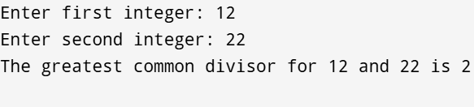

**Practice task 2:**

#include <iostream>

using namespace std;

int main() {

int limit;

cout << "Enter the limit: ";

cin >> limit;

if (limit < 1) {

cout << "Please enter a positive integer greater than 0." << endl;

return 1; // Exit if input is invalid

}

cout << "Integers from 1 to " << limit << " are:" << endl;

for (int i = 1; i <= limit; ++i) {

cout << -i << " " << i << " ";

}

cout << endl; // Move to a new line after the output

return 0;

}

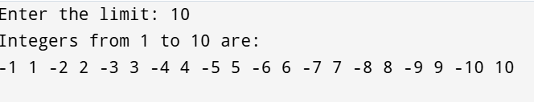

**Practice task 3:**

#include <iostream>

using namespace std;

int main() {

int n = 10;

long long first = 0, second = 1, next;

cout << "The first 10 Fibonacci numbers are:" << endl;

cout << first << " " << second << " ";

for (int i = 3; i <= n; ++i) {

next = first + second;

cout << next << " ";

first = second;

second = next;

}

cout << endl;

return 0;

}

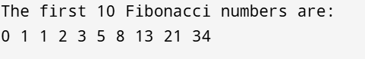

**Practice task 4:**

#include <iostream>

#include <iomanip>

using namespace std;

int main() {

int num_items;

float price, total_price = 0.0, discount = 0.1, tax_rate = 0.08, total_with_tax;

cout << "Enter the number of items in the cart: ";

cin >> num_items;

for (int i = 1; i <= num_items; ++i) {

cout << "Enter the price of item " << i << ": $";

cin >> price;

total_price += price;

}

if (total_price > 100) {

total_price -= total_price * discount;

cout << "A 10% discount has been applied." << endl;

}

total_with_tax = total_price + (total_price * tax_rate);

cout << fixed << setprecision(2);

cout << "Total cost before tax and discount: $" << total_price + (total_price * discount) << endl;

cout << "Total cost after discount (if applicable): $" << total_price << endl;

cout << "Total cost after tax: $" << total_with_tax << endl;

return 0;

}

